**NovaTest GC Software Development Requirements**

1. **Main screen**

In Main Screen, it includes the following menus:

**Method, Calibrate, Test, Data Analysis, Report, Library**

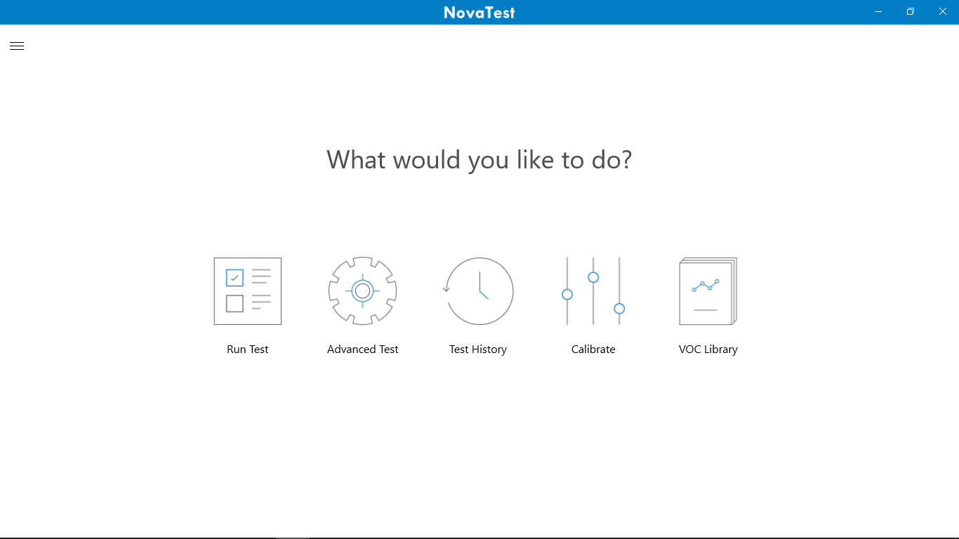

Data Analysis

Library

Report

Test

Method

Calibrate

1. “**Method**” icon has a pull-down menu, it includes the following submenus:

“Create a method”, “Modify a method”

1. When click “Create a method”, the following screen will show:

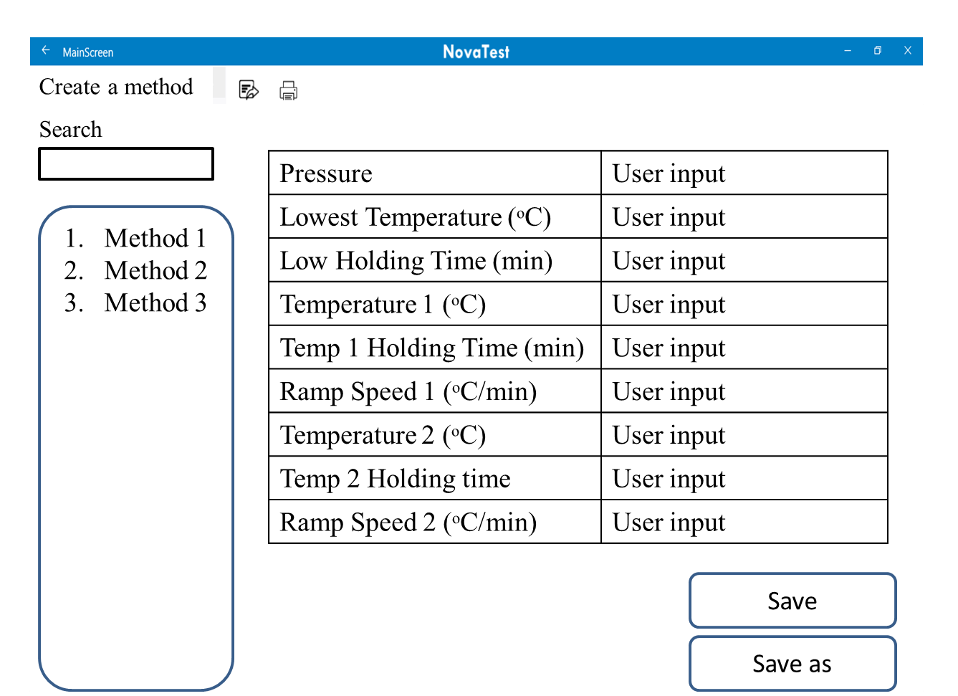

1. When click “Modify a method”: user can modify an existing method
2. “**Calibrate**” icon has a pull-down menu, it includes the following submenus: Create a calibration curve, View a calibration curve.
3. When click “Create a calibration curve”
4. It will show a table, take BTEX as an example:

|  |  |  |  |  |  |  |
| --- | --- | --- | --- | --- | --- | --- |
| Standard gas name | | BTEX | | |  |  |
| Calibration point | Compound Name | | Sampling time, min | Concentration (ppbv) | Choose a method |  |
| 1 | Benzene | | User input | User input | The method user chooses | Run |
| Toluene | | User input |
| Ethylbenzene | | User input |
| m, p-xylene | | User input |
| o-xylene | | User input |
| 2 | Benzene | | User input | User input | This method is the same as row 1 | Run |
| Toluene | | User input |
| Ethylbenzene | | User input |
| m, p-xylene | | User input |
| o-xylene | | User input |

The user can type in the standard gas name

The user can choose the number of calibration point. When click “”, the table will add one more row.

The user can choose the number of compounds to be calibrated. When click “”, it will show “Benzene, Toluene, Ethylbenzene, m, p-xylene, o-xylene”. The user can choose which compound to calibrate and it will be automatically added to the table.

The user can choose an existing method to run the calibration curve. A set of calibration curve just use one method.

The user will manually type in the sampling time and standard gas concentration.

When the user clicks “Run” in the table, the device will run this selected row.

b. Generate calibration curve: **the user can choose to use which row in the table to generate the calibration curve.**

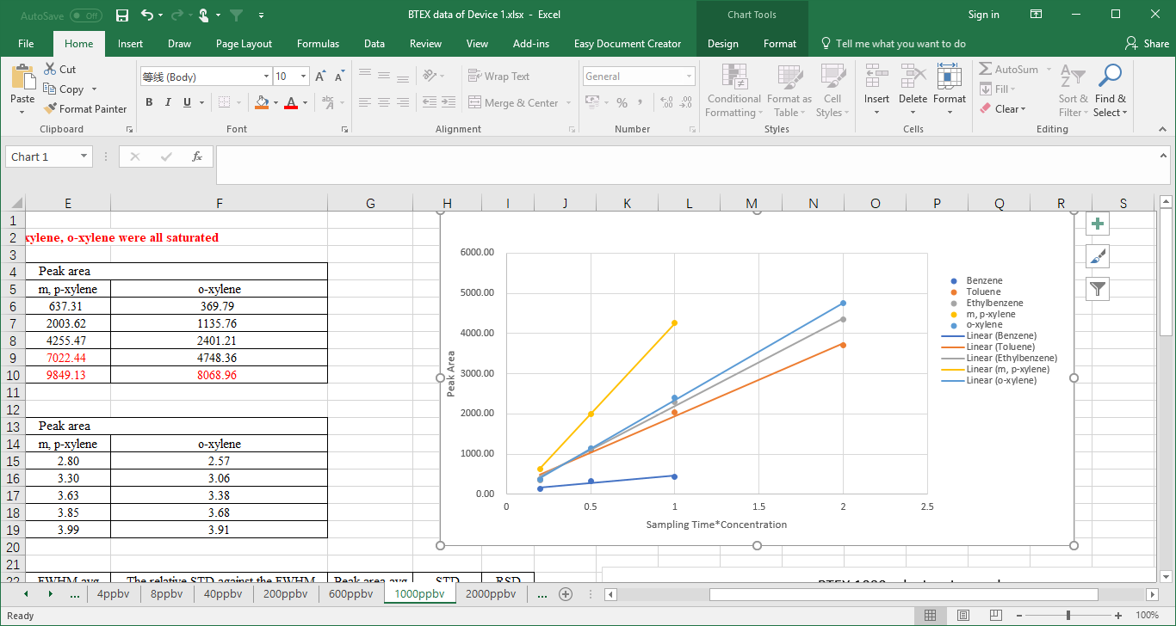

|  |  |  |  |  |
| --- | --- | --- | --- | --- |
| Compound Name | Calibration Equation | R2 | Calibration range | Retention time |
| Benzene | y1=k1x1+b |  |  |  |
| Toluene | y2=k2x2+b |  |  |  |
| Ethylbenzene | y3=k3x3+b |  |  |  |
| m, p-xylene | y4=k4x4+b |  |  |  |
| o-xylene | y5=k5x5+b |  |  |  |

c. Save/save as the calibration as user defined name.

(2) View a calibration curve

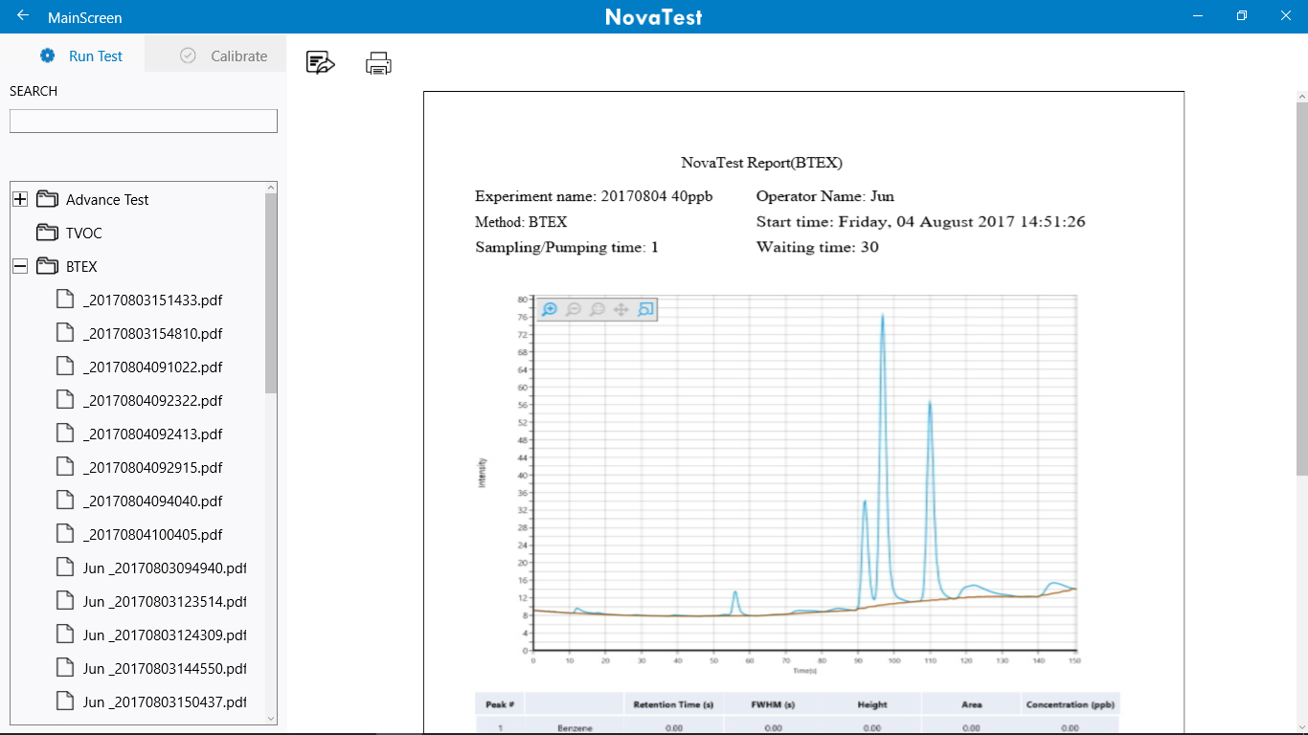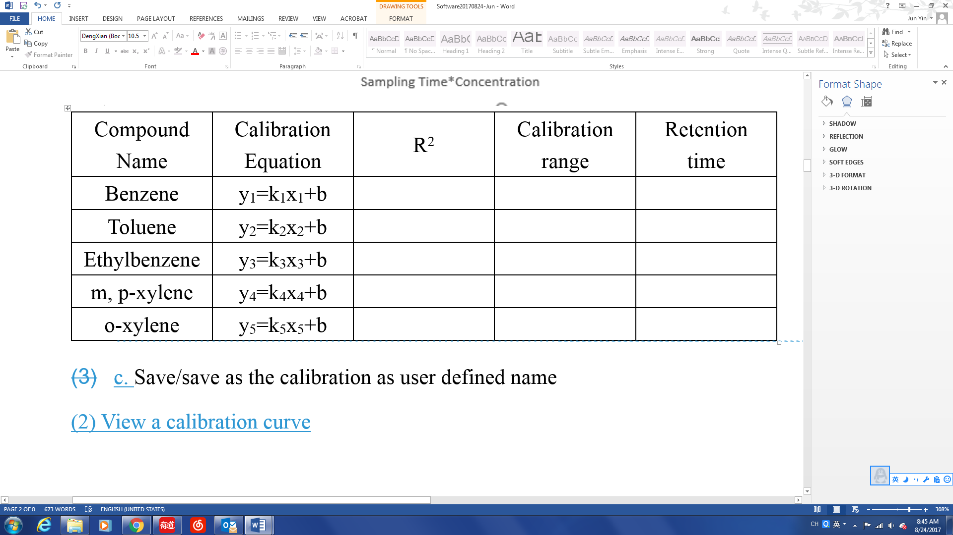

Calibration Curve Name

ve

1. Under the “**Test**” function, the user chooses certain method to run tests

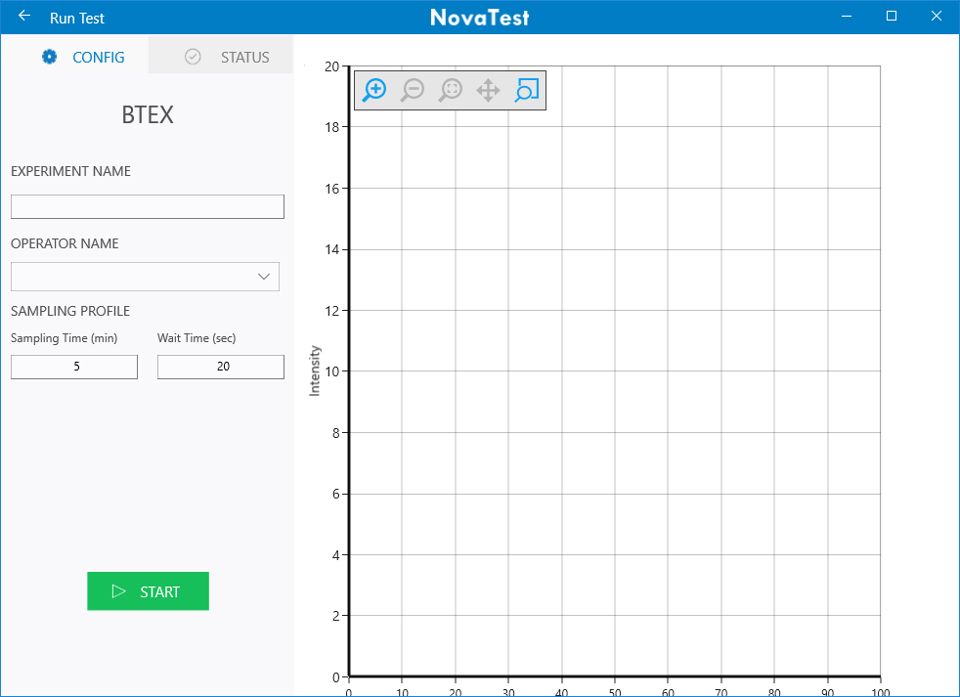

**Choose calibration curve**

**(pull-down menu)**

**Save**

**Save as**

**Choose a method (pull-down menu)**

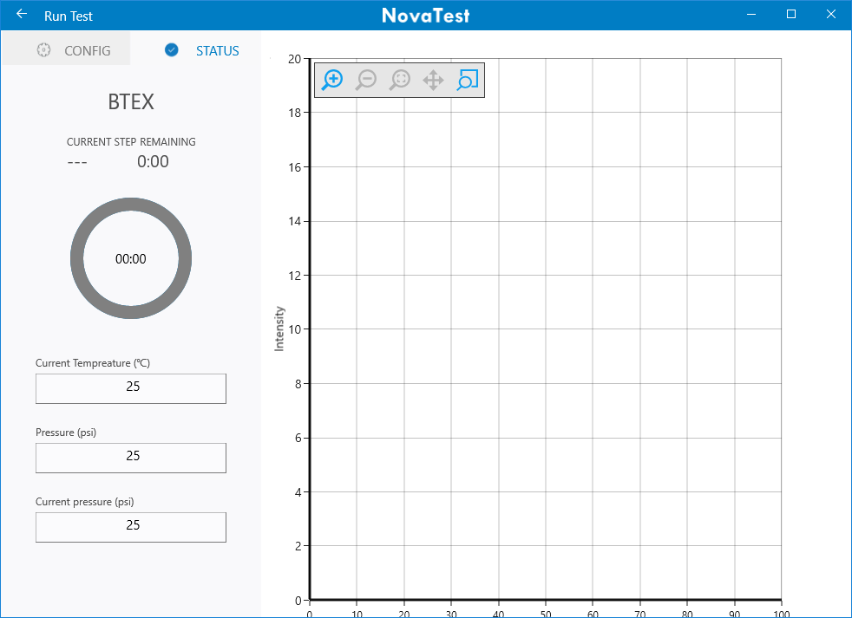

When test is finished, one data file will be created and named the same as the “experiment name” to a folder named as **Data**.

Meanwhile, a table will show under the graph, show the results generated by the software. If user is unsatisfied with the integration, he/she can choose to process the data under “Data Analysis” Menu.

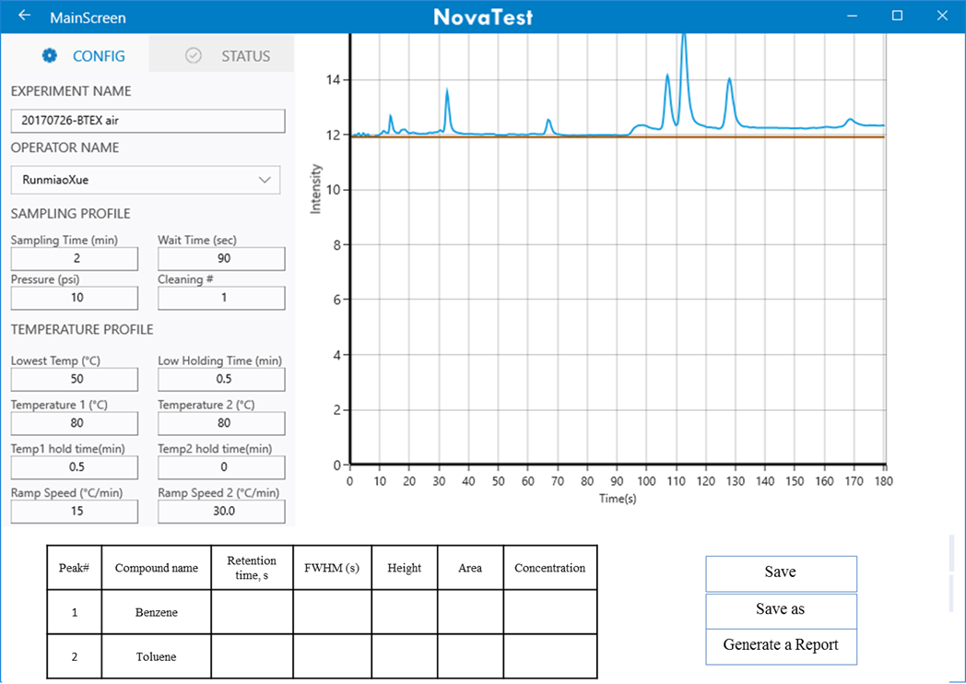

1. Under the “**Data Analysis**” function, the user can select certain data file to process the data:

When open a data file, a chromatogram will show.

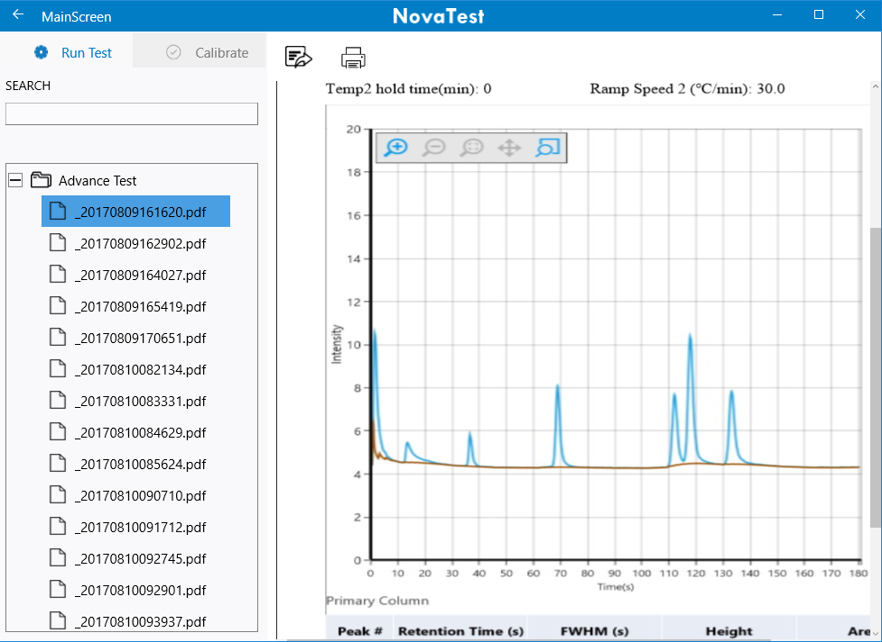

The user can use the following functions to process the data on the chromatogram:

1. Zoom in and zoom out
2. Back to original
3. Manually select peak, and then the software will integrate the select peak with user defined baseline.
4. Unselect certain peak (don’t mark the peak and integrate the peak area) and delete the information in the table beneath.
5. Move or adjust the peak window to match the slightly drifted peak and correct the integration.
6. Auto integrate peaks with height higher than certain value. The value can be adjusted by the user.
7. Change X range and show the graph
8. Change Y range and show the graph
9. Auto smoothing
10. Show the signal to noise ratio for selected peak to selected baseline

A table will show and the result in the table will change simultaneously when user processes the data.

Here is a template for the table:

|  |  |  |  |  |  |  |  |  |
| --- | --- | --- | --- | --- | --- | --- | --- | --- |
| Peak # | Compound Name | Retention time, second | Peak area | Peak Height | FWHM | Calibration curve, R2 | Method detection limit | Concentration |
|  |  |  |  |  |  | Choose the saved calibration curve |  |  |
|  |  |  |  |  |  | Choose the saved calibration curve |  |  |
|  |  |  |  |  |  | Choose the saved calibration curve |  |  |
|  |  |  |  |  |  | Choose the saved calibration curve |  |  |
|  |  |  |  |  |  | Choose the saved calibration curve |  |  |

Save

Save as

Generate a Report

In the table, user can choose certain calibration curve and the concentration will be calculated.

After data processing, the user can select what result (columns in the table) to show in the report file

If click the “Save” or “Save as” icon, a processed data file will be generated and saved to “Data” file. This file can be reused for data analysis if needed.

If click the “Generate a Report” icon, a PDF format report will be generated under the “Report” menu. The user can name the report.

1. Under the “**Report**” function:



ve

**Show as the report template**

Here is a Report template:



NovaTest Report

Experiment Name: Operator Name:

Date: 08/22/2017 6:00 pm

Instrument: NovaTest P100

Method: Sampling/Pumping Time (min): Waiting Time (second):

Pressure (psi):

Lowest Temperature (ᵒC): Low Holding Time (min):

Temperature 1 (ᵒC): Temp 1 Holding Time (min)

Ramp Speed 1 (ᵒC/min) Temperature 2 (ᵒC):

Temp 2 Holding Time (min): Ramp Speed 2 (ᵒC/min):



|  |  |  |  |  |  |  |
| --- | --- | --- | --- | --- | --- | --- |
| Peak# | Compound | Retention Time(s) | FWHM(s) | Height | Area | Concentration(ppb) |
| 1 |  |  |  |  |  |  |
| 2 |  |  |  |  |  |  |
| 3 |  |  |  |  |  |  |
| 4 |  |  |  |  |  |  |
| 5 |  |  |  |  |  |  |